Date:15\10\26
C01-Assessment Tool-3
(CODING CHALLENGE QUESTIONS)
Course code:DSA0308
Course Name:Natural Language Processing
Name:P.Varshini
Reg no:192472372
Q-1
Section 1: Intelligent Email and Password Validator using Regular Expressions
1. Problem Statement:
A software company is developing a user registration system. Before creating an account, the system must validate user credentials based on predefined security policies.
ANSWER:
CODE:
import re
# Email validation
def validate_email(email):
pattern = r'^[A-Za-z][A-Za-z0-9._]*@[A-Za-z]+\.(com|org|edu|net|in)$'
if re.fullmatch(pattern, email):
print("Valid Email")
else:
print("Invalid Email")
# Password validation
def validate_password(password):
pattern = r'^(?=.*[A-Z])(?=.*[a-z])(?=.*\d)(?=.*[@#$%&!])[A-Za-z\d@#$%&!]{8,}$'
if re.fullmatch(pattern, password):
print("Strong Password")
else:
print("Weak Password")
# Mobile number validation
def validate_mobile(mobile):
pattern = r'^[6-9]\d{9}$'
if re.fullmatch(pattern, mobile):
print("Valid Mobile Number")
else:
print("Invalid Mobile Number")
# Get user input
email = input("Enter Email Address: ")
password = input("Enter Password: ")
mobile = input("Enter Mobile Number: ")
# Validate credentials
validate_email(email)
validate_password(password)
validate_mobile(mobile)
INPUT:
Enter Email Address: varshini123@gmail.com
Enter Password: Varshini@123
Enter Mobile Number: 9876543210
OUTPUT:
Valid Email
Strong Password
Valid Mobile Number
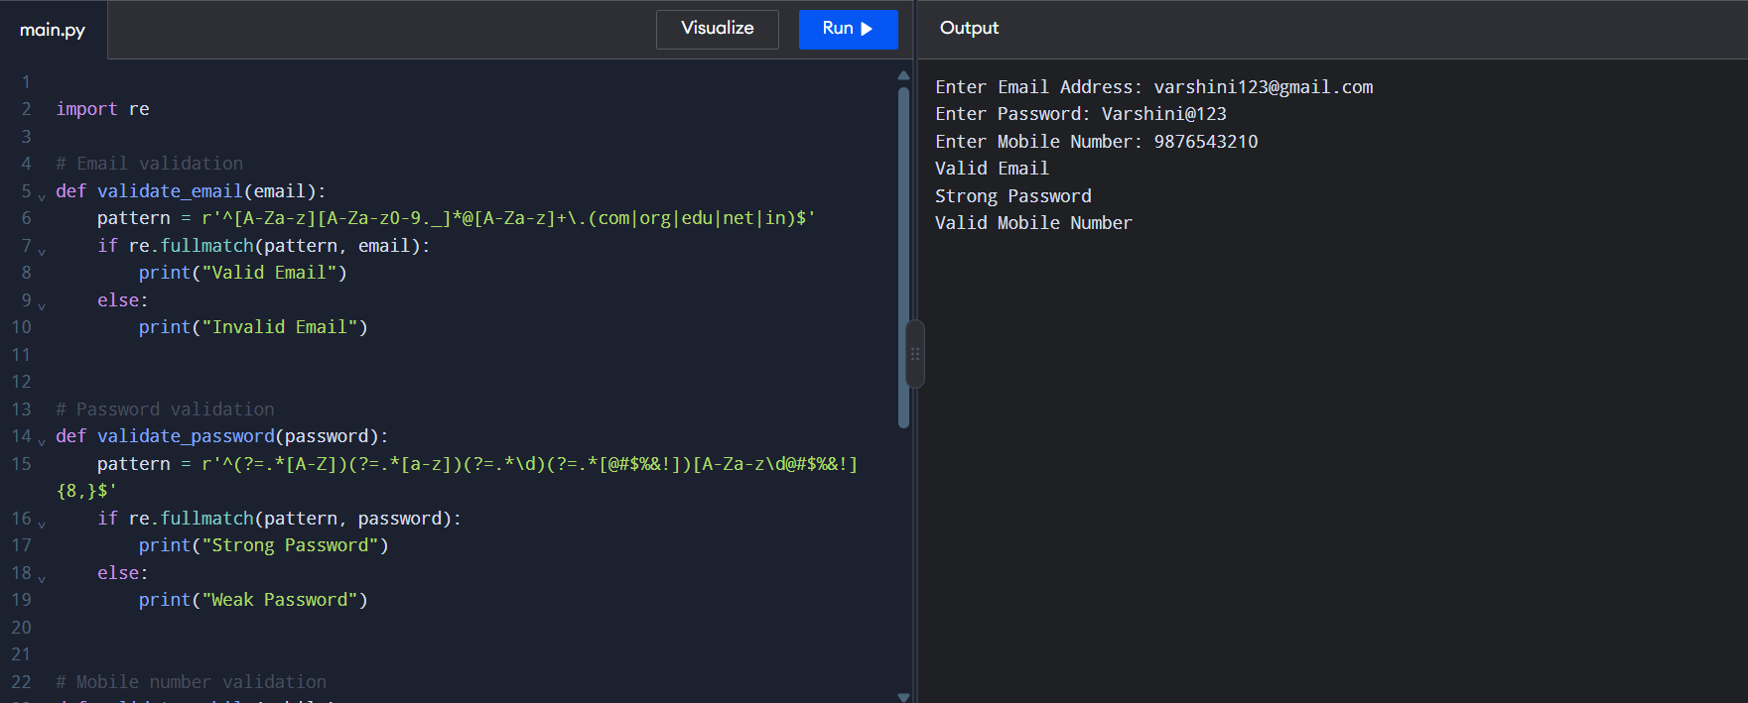
Q-2
Section 2: Design a Finite State Automata (FSA) Simulator
2. Problem Statement
Develop a Python-based Deterministic Finite Automata (DFA) simulator.
ANSWER:
CODE:
# DFA Simulator in Python
# Accept DFA description
states = input("Enter states (space-separated): ").split()
alphabet = input("Enter input alphabet (space-separated): ").split()
initial_state = input("Enter initial state: ")
final_states = input("Enter final states (space-separated): ").split()
# Create transition table
transition = {}
print("Enter transitions for each state and input symbol:")
for state in states:
transition[state] = {}
for symbol in alphabet:
next_state = input(
f"Transition from {state} on {symbol}: "
)
transition[state][symbol] = next_state
# Accept multiple input strings
n = int(input("Enter number of input strings: "))
for _ in range(n):
string = input("Enter input string: ")
current_state = initial_state
path = [current_state]
valid = True
for symbol in string:
if symbol not in alphabet:
valid = False
break
current_state = transition[current_state][symbol]
path.append(current_state)
print("Transition Path:", " -> ".join(path))
if valid and current_state in final_states:
print("Accepted")
else:
print("Rejected")
INPUT:
Enter states (space-separated): q0 q1 q2
Enter input alphabet (space-separated): a b
Enter initial state: q0
Enter final states (space-separated): q2

Enter transitions for each state and input symbol:
Transition from q0 on a: q1
Transition from q0 on b: q0
Transition from q1 on a: q1
Transition from q1 on b: q2
Transition from q2 on a: q1
Transition from q2 on b: q0
Enter number of input strings: 3
Enter input string: abaab
Enter input string: aab
Enter input string: abb
OUTPUT:

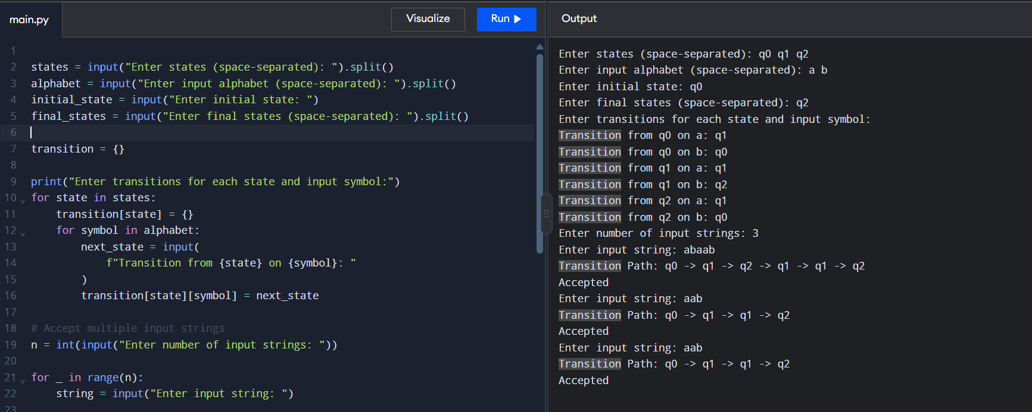
Q3
Section 3: Smart Pattern Matching Engine using Regular Expressions
3. Problem Statement
Develop a Python-based text search engine that performs pattern matching using Regular Expression.
ANSWER:
CODE:
import re

def smart_pattern_matching():
text = input("Enter the text: ")
pattern = input("Enter the search pattern (Regex): ")

try:
matches = list(re.finditer(pattern, text))

if matches:
print("\nPattern Matched Successfully!")
print("Number of matches:", len(matches))

for i, match in enumerate(matches, start=1):
print(f"Match {i}: {match.group()}")
print(f"Position: {match.start()} to {match.end()}")
else:
print("\nNo matching pattern found.")
except re.error as e:
print("Invalid regular expression:", e)
smart_pattern_matching()
INPUT:
Enter the text: Python is easy. Python is powerful.
Enter the search pattern (Regex): Python
OUTPUT:
